**LAB#13**

**IMPLEMENTING METAHEURISTIC ALGORITHM**

**(Genetic Algorithm)**

**OBJECTIVE:**

Solving Coin Toss Problem by implementing Genetic Algorithm (GA).

**LAB TASK:**

1. Run the given code of Genetic Algorithm (Coin Toss Problem) and show the output.

**Code:**

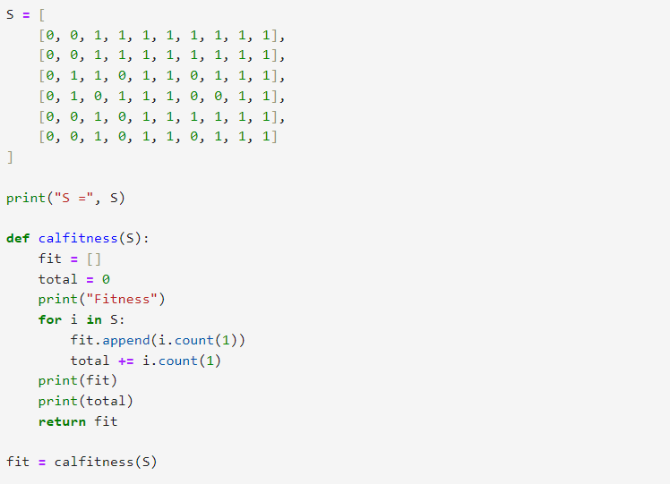

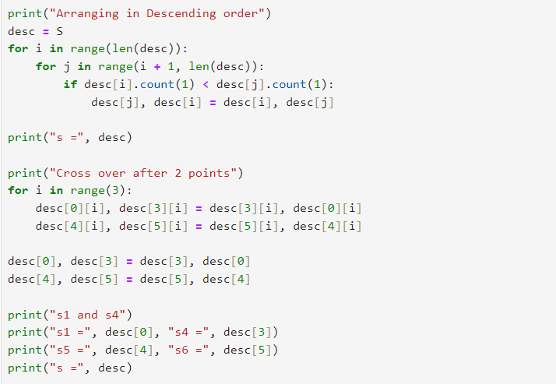

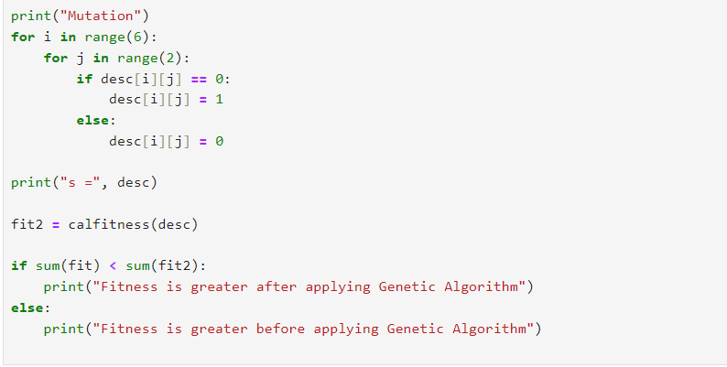

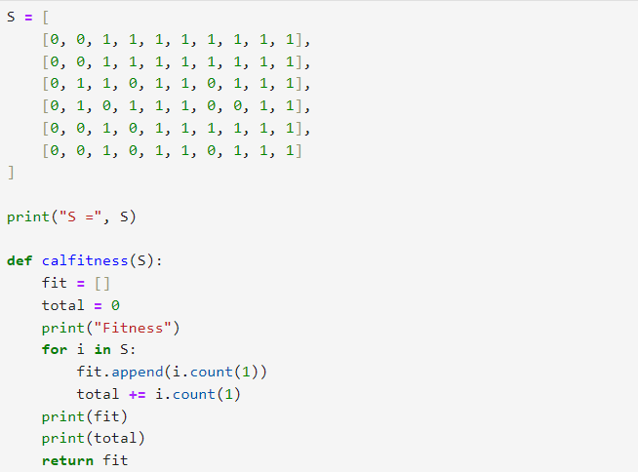

1. In given code there are crossover functions implemented between S1, S4 and S5, S6 after 3rd point. You can perform crossover between S2 and S3 after 4th point.

**CODE:**

**Output:**

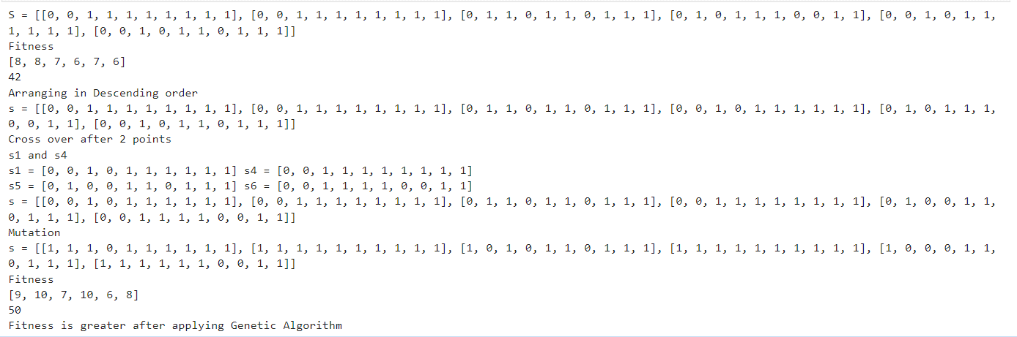

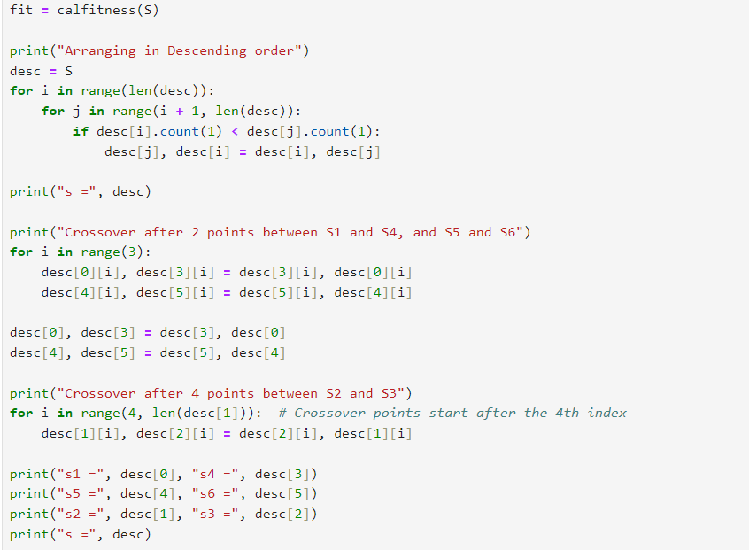

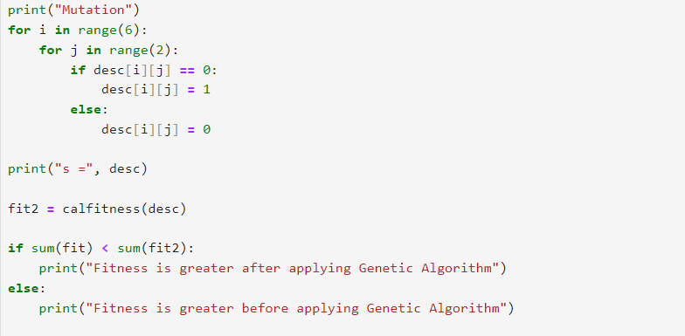

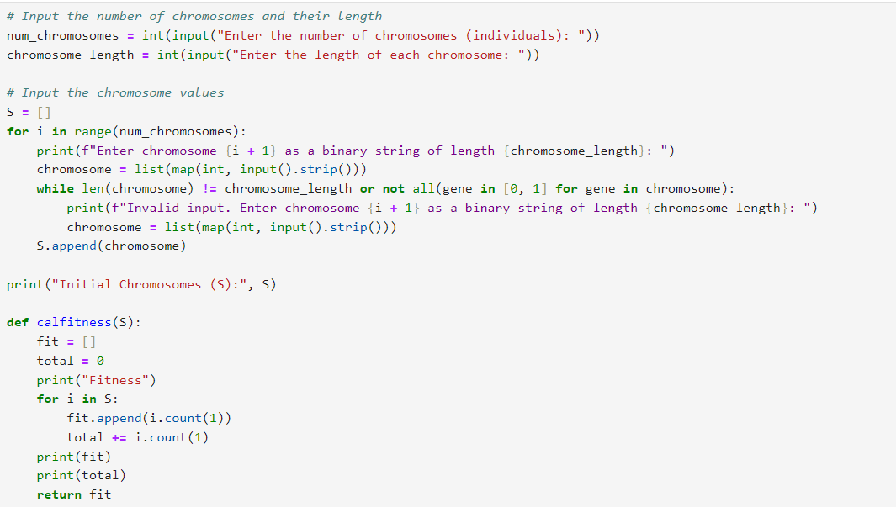

1. In given code the values of chromosomes are hardcoded, you may take input values of chromosomes at run time.

**CODE:**

**Output:**

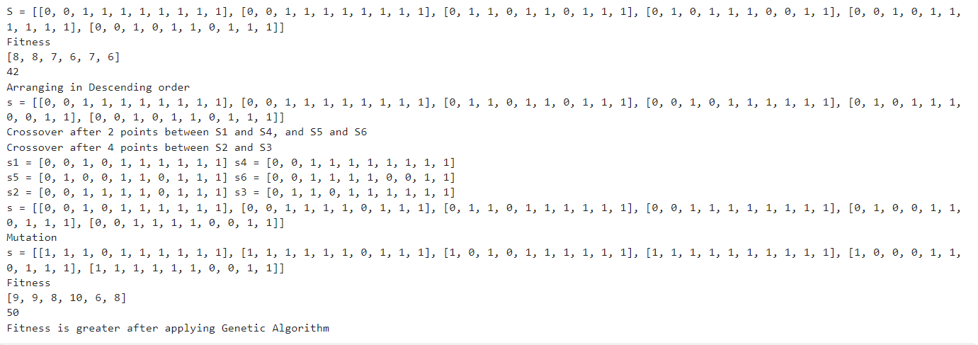

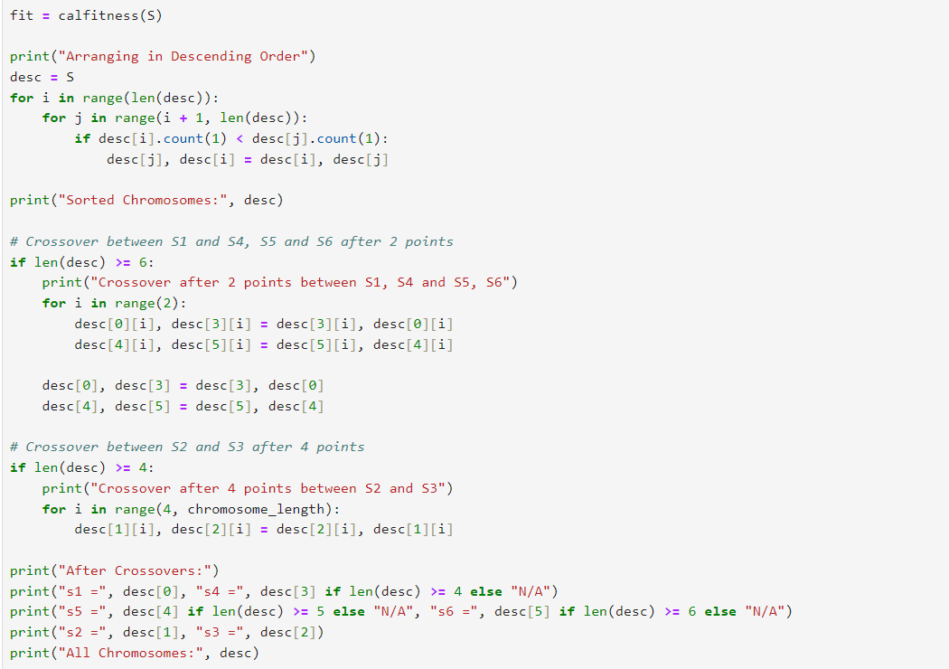

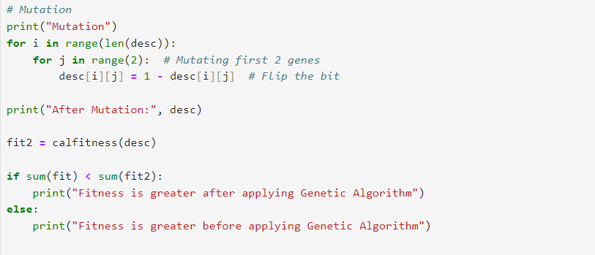

**Output:**

